Project Development Phase Delivery of Sprint-1

|  |  |
| --- | --- |
| TEAM ID | PNT2022TMID18163 |
| PROJECT TITLE | INDUSTRY-SPECIFIC INTELLIGENT FIRE MANAGEMENT SYSTEM |

BUILDING PHASE:

TO Create the Watson Assistant Service and IOT Platform:

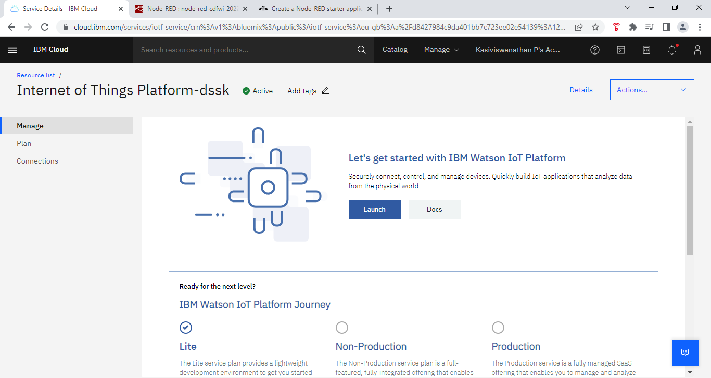

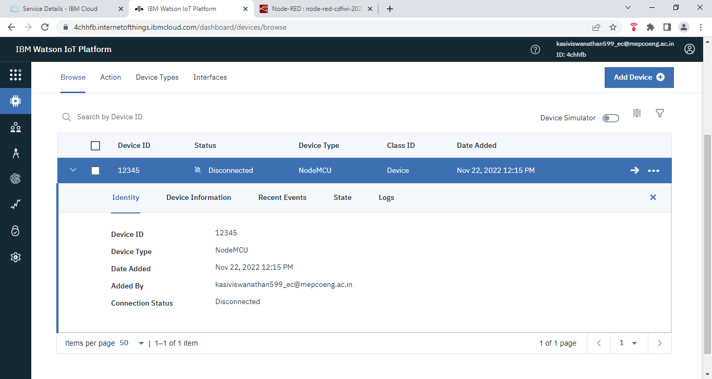

Choosing the location:





